Circle Language Spec: Commands

Command Reference in a Diagram
The principle of command references is explained in the article Command Reference. The current article demonstrates the expression of it in a diagram.

A command reference is displayed in a diagram as a diamond or square connected to another diamond or square with a solid line.

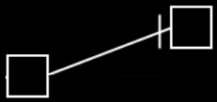

It does not matter whether it is squares or diamonds, because the only difference between a square and a diamond, is that a square can not be executed and a diamond can.

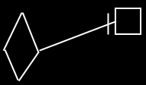

Direction of the line must be indicated with an access mark, unless the line is going outwards:

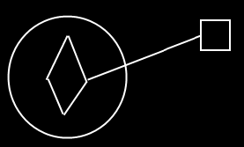

You can not execute an active command object through an inactive command reference.

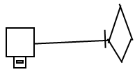

But with an executable reference to an inactive reference to an executable command you can execute the command object again.

